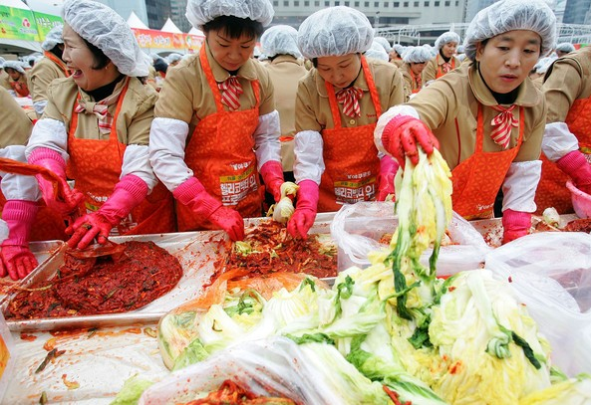
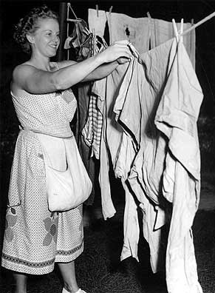
A housewife’s guide to paper writing

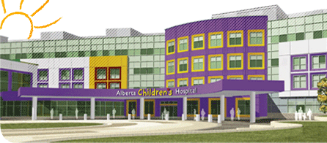
Susa Benseler, MD PhD Section of Rheumatology Alberta Children’s Hospital Calgary, Canada

Concept:
- Prep work: Team, journal, authors guidelines
- reference manager program (endnote, other)
- Title (sexy)
- Authors aﬃlia1ons
Based on your results you write your introduction so the next step in writing your manuscript is methods and results

Methods/patients (6 paragraphs):

Paragraph 1: Study design, patients, time frame, inclusion, exclusion criteria, data capture, ethics (No)
Paragraphs 2 to 4: independent variable descrip1on (clinical, lab, imaging, treatment)
Paragraph 5: outcome (primary, secondary) and outcome measure
Paragraph 6: Analysis (what tests, software)

Results/tables and graphs:
Corresponding paragraphs to methods

Concepts:

– Informa1on can be found in either, written info is usually important summary data or unimportant data
– Avoid duplications, refer tables at the end of the summary data

Background (4 paragraphs)
Paragraph 1: Disease of interest (4 sentences, max of 5 ref)
Paragraph 2: Problem of interest (4 sentences, max of 5 ref)
Paragraph 3: Gap of knowledge (3 sentences, no ref)
Paragraph 4: Therefor the aims of the study were (max 3 aims):
- Description
- Comparison
- prediction/punchline analysis

Discussion (5 paragraphs):
Paragraph 1: Summary highligh1ng the unique aspects of the study (1.sentence), then 3 sentences to summarize
Paragraph 2: first Key point of the study: make the point (1.sentence), support the point (2.), turn around and compare with literature (max 3 sentences with reference), may ﬁnish with “motherhood statement
Paragraph 3: second Key point of the study: make the point (1.sentence), support the point (2.), turn around and compare with literature (max 3 sentences with reference), may ﬁnish with “motherhood statement
Paragraph 4: limita1ons (max 3), pair with however sentence
Paragraph: conclusion (3 sentences)

Acknowledgement:
References: the software will take care of the arrangement and style
Tables and ﬁgures

