### *This will allow you to* ***SEE*** *the MD Progress Notes*.

# ADD MD Progress Notes to Document Review

Use this option to modify an existing list.

1. Login. At the top, select **Preferences**, then **Document Review**
2. The **Personal Document View Options** window will pop up. Choose **Document Selection** tab (note: you may need to use the arrows to the right or left of the headings to find it). Once highlighted, click the **Modify Documents** (screwdriver)icon in the top left corner.

**Note**: Choose **Set as Default** for the document(s) which will automatically show up when you log in.

* 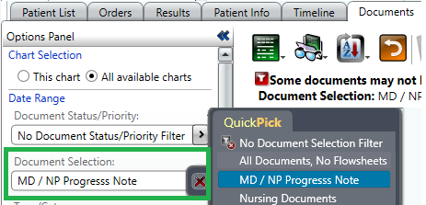**No Document Selection Filter** (automatic default) will show ALL documents (including Nursing, Allied Health and MD notes)
* **Physician Documents** will show MD/NP documents (NOT Nursing)

You can always change your Document Selection using the drop-down on the left-side, main screen.

1. In the **Modify Document** **Selection** window, there are two options:
   1. Use **Document Entry Browse** -> **Inpatient** -> **MD Progress Note** *OR*
   2. Use **Document**, and in the **Enter Document** field type ‘MD’; the **MD Progress Note** will show up.

Select the **MD Progress Note** (left pane), and click **Add** which will move it over (right pane).

At the top, enter a **Name** (e.g. ‘MD Progress Notes’), then click **OK** (bottom right). Then it will be listed in your Document Selection.

# ADD MD Progress Notes to Document Review

Use this option to curate your own, personalized document list.

1. Login. At the top, select **Preferences**, then **Document Review**
2. The **Personal Document View Options** window will pop up. Choose **Document Selection** tab (note: you may need to use the arrows to the right or left of the headings to find it). Once highlighted, click the **Add Documents** icon in the top left corner.

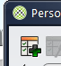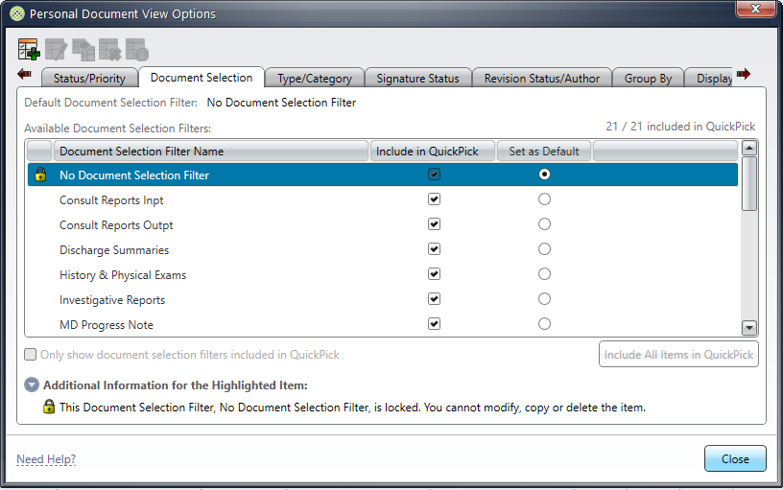

1. In the **Add New Document** window, there are two options:
   1. Use **Document Entry Browse** -> **Inpatient** -> **MD Progress Note** OR
   2. Use **Document**, and in the **Enter Document** field type ‘MD’; the **MD Progress Note** will show up.

Select the **MD Progress Note** (left pane), and click **Add** which will move it over (right pane).

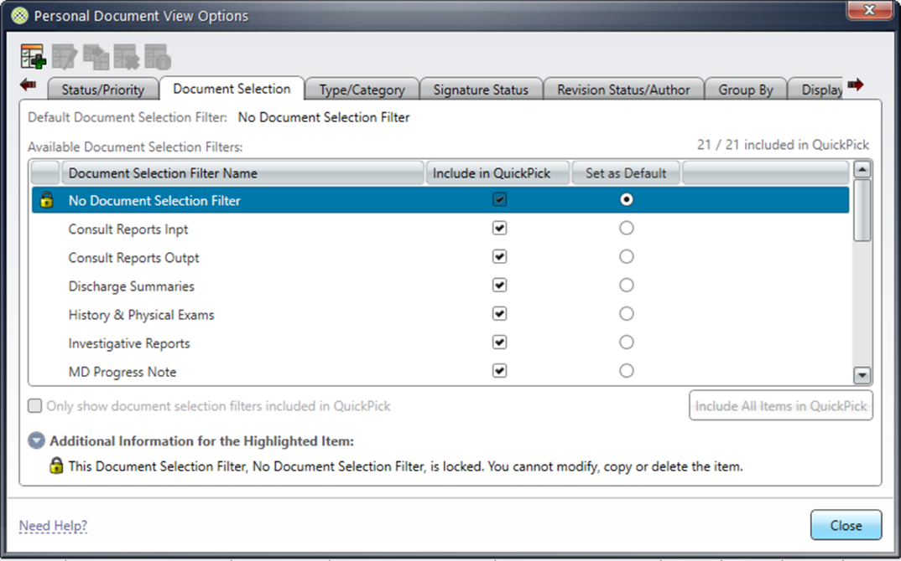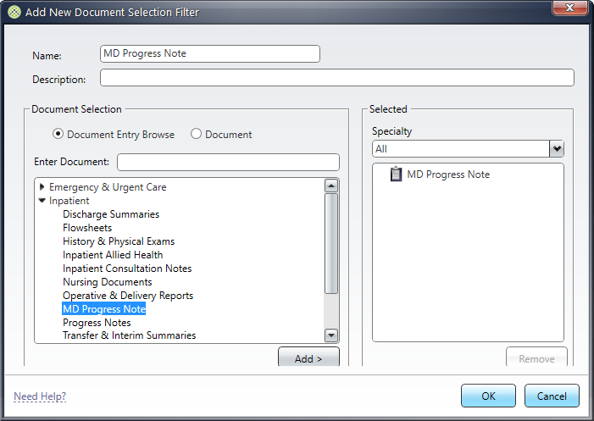At the top, enter a **Name** (e.g. ‘MD Progress Notes’), then click **OK** (bottom right). Then it will be listed in your Document Selection.



**Note**: Choose **Set as Default** for the document(s) which will automatically show up when you log in.

* **No Document Selection Filter** will show ALL documents (including Nursing, Allied Health and MD notes)
* **Physician Documents** will show ALL MD/NP documents (NOT Nursing, Allied Health)

You can always change your Document Selection using the drop-down on the left-side, main screen.