GUIDE TO THE
MEDICAL SCHOOL SELF-STUDY
for visits in 2024-2025

FOR MEDICAL EDUCATION PROGRAMS
LEADING TO THE M.D. DEGREE

Published February 2023

For further information, contact:
CACMS Secretariat
Committee on Accreditation of Canadian Medical Schools
10th Floor, 150 Elgin Street
Ottawa, Ontario, Canada K2P 1L4
Email: cacms@afmc.ca

Visit the CACMS website at:
https://cacms-cafmc.ca/

Guide to the Medical School Self-Study
For medical education programs leading to the M.D. Degree

©Copyright February 2023 by the Committee on Accreditation of Canadian Medical Schools. All rights reserved. All material subject to this copyright may be reproduced, with citation, for the noncommercial purpose of scientific or educational advancement.

Table of Contents
1. Purpose of the Guide to the Medical School Self-Study 4
2. Assistance from the CACMS Secretariat 4
3. MSS Process and Report Overview 4
4. Preparation for the MSS 4
4.1 MSS Leadership 4
4.2 Steering committee membership 4
4.3 Subcommittees to the MSS steering committee 5
5. Drafting preliminary responses to MSS element evaluation forms 6
5.1 Obtaining the correct forms 6
5.2 Gathering evidence 6
5.3 Completing the MSS element evaluation form 8
5.3.1 Completing the analysis of each requirement 8
5.3.2 Completing the Requirement Assessment table 8
5.3.3 Completing the Overall Element Rating table 9
5.3.4 Completing the Continuous Quality Improvement (CQI) recommendations 9
5.3.5 Submitting subcommittee reports to the steering committee 9
6. Writing the MSS report 10
6.1 Title page 10
6.2 Table of contents 10
6.3. Introduction 10
6.4. Evaluation of elements 10
6.5 MSS steering committee summary statement 10
6.6 Appendix 11
7. Submission of MSS report 11
8. Appendices 11
Appendix 5.3.3 11
Appendix 6.4 12

1. Purpose of the Guide to the Medical School Self-Study

The Guide to the Medical School Self-Study (MSS) is a compendium of the information needed by a medical school to conduct the MSS process and complete the MSS report. This guide is meant to be read in conjunction with the Guide for the Conduct of CACMS Accreditation Visits and the CACMS Accreditation Visit Report Writing Guide, both of which are available on the CACMS website in the accreditation documents tab.

2. Assistance from the CACMS Secretariat

Preparation sessions for medical schools with upcoming accreditation visits are organized by the CACMS Secretariat in collaboration with the medical school’s administration. These sessions provide general information about accreditation including the self-study process and give participants an opportunity to discuss their questions/concerns with members of the Secretariat. At any time during the MSS process, those leading the MSS are encouraged to contact the CACMS Secretariat with their questions via email addressed to: cacms@afmc.ca.

3. MSS Process and Report Overview

The medical school self-study (MSS) process consists of a systematic and iterative self-evaluation of the medical school based on information from the Data Collection Instrument (DCI) and the Independent Student Analysis (ISA).
The MSS process is led by a steering committee and functions best when its membership is broadly representative of the constituencies of the medical school (discussed in Section 4.2, below). The Faculty Undergraduate Accreditation Lead (FUAL) is often the key liaison between the medical school administration and the MSS steering committee.

The Steering Committee also strikes subcommittees to evaluate each of the accreditation standards and elements.

Each medical school, considering its specific context, is left to make its own decisions about the terms of reference of its steering committee and any related subcommittees.

At the end of the MSS process, the Steering Committee generates an MSS report (discussed in Section 6) that has, through an iterative process, considered the medical school’s Data Collection Instrument (DCI), the Independent Student Analysis (ISA) report, and its various subcommittee reports. The MSS report can be used by the medical school to guide improvements in advance of an accreditation visit and in advance of its submission of the DCI to the CACMS. The medical school is free to use the MSS report for its own continuous quality improvement (CQI) program. The final MSS report is a required part of the medical school’s submission of accreditation documents to the CACMS.

4. Preparation for the MSS

4.1 MSS Leadership
An early step in a medical school’s preparation for the MSS is to appoint the leader(s) of the MSS steering committee. The FUAL can be appointed to chair the steering committee, but many schools choose a dean or other senior faculty member familiar with undergraduate accreditation as chairperson and appoint the FUAL as a liaison between the steering committee and the medical school’s senior administration. The steering committee chair is responsible for writing the MSS report.

4.2 Steering committee membership
The steering committee chair, FUAL and senior administration in consultation can select the remaining members of the steering committee drawing on members that reflect the breadth and diversity of interests, experiences, geographic locations, and skills that will best serve the medical school in completing the MSS. The medical school is advised to provide administrative staff assistance to facilitate the timely completion of the MSS and writing of the MSS report.

Consideration is often given to having representation from the following constituencies:
- medical school senior academic and administrative leaders
- department chairs/heads of sections
- junior and senior faculty members
- medical students
- medical school graduates
- faculty members and/or administrators of the university but outside of the medical school
- representatives of clinical affiliates
- trustees (regents) of the medical school/university
- graduate students
- residents involved in medical student education
- community physicians

Each school must make its own decisions about membership based on its specific circumstances. Having knowledgeable representation from each campus helps ensure validity of the MSS committee’s conclusions. The MSS steering committee might be chaired by the dean or by a vice dean, senior associate dean, department chair, or senior faculty member.

4.3 Subcommittees to the MSS steering committee
Various subcommittees of the MSS steering committee are needed, as each of the 96 elements within the 12 accreditation standards must be evaluated in the MSS process.

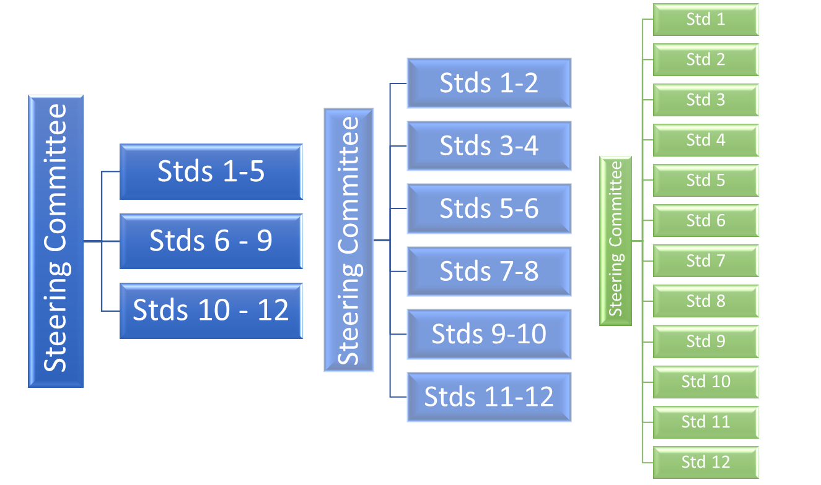
Some schools structure the subcommittees such that each subcommittee addresses only one standard. Others may choose a strategy where a given subcommittee evaluates two or more standards. When schools choose to have a subcommittee address more than one standard, they may opt to group the standards by content areas as demonstrated in the figure below.

Another option is for schools to structure subcommittees around groupings of elements by topic or interest group that is independent of any single standard.

Schools may wish to create additional subcommittees to review specific topics, either to undertake a more detailed review or to accommodate unique medical school needs. A school with more than one campus, for example, may want to create a separate subcommittee to review each campus, or a school may structure additional committees to review each of its missions and their relationship to the medical education program.

Subcommittee chairs need not be senior faculty members nor members of the educational leadership. Having at least one content knowledgeable member on each subcommittee will help ensure that the subcommittees stay on task. For example, a member of the curriculum committee could be considered for the subcommittee evaluating standard 8, Curricular management, Evaluation, and Enhancement; or a senior administrator could be considered for the subcommittee on Standard 2, Leadership and Administration. Students often can provide meaningful context to the deliberations of the subcommittees and can be considered for membership. Steering committee members serving on subcommittees can help provide continuity and facilitate communication between the subcommittee and the steering committee. Subcommittee function is further described in Section 5.

5. Drafting preliminary responses to MSS element evaluation forms

5.1 Obtaining the correct forms
As many accreditation documents are revised annually, the medical school must ensure that it uses the documents for the academic year (spring or fall) in which the accreditation visit will take place. These documents are available from the CACMS website in the accreditation documents section.

The MSS element evaluation forms along with the CACMS definitions for element satisfaction ratings are to be distributed to the MSS subcommittees as appropriate. The element satisfaction definitions used in the forms are found in the CACMS Rules of Procedure and in Section 5.3.3 of this Guide.

5.2 Gathering evidence
Before the subcommittees can begin their work, each subcommittee must be provided the appropriate section of the DCI and be instructed to read the applicable DCI sections and any related appendices in their entirety. Some standards include data tables from the Independent Student Analysis (ISA), but early in the MSS process, neither the MSS steering committee nor the subcommittees will likely have access to either the student’s analysis of the ISA tabular data or the analysis of the four open-ended questions asked of the students as part of the ISA. The final ISA report may only become available a few months before the accreditation visit.

Responses to the indicator questions in the DCI comprise the medical school administration’s evidence for satisfaction with the requirements of each element.

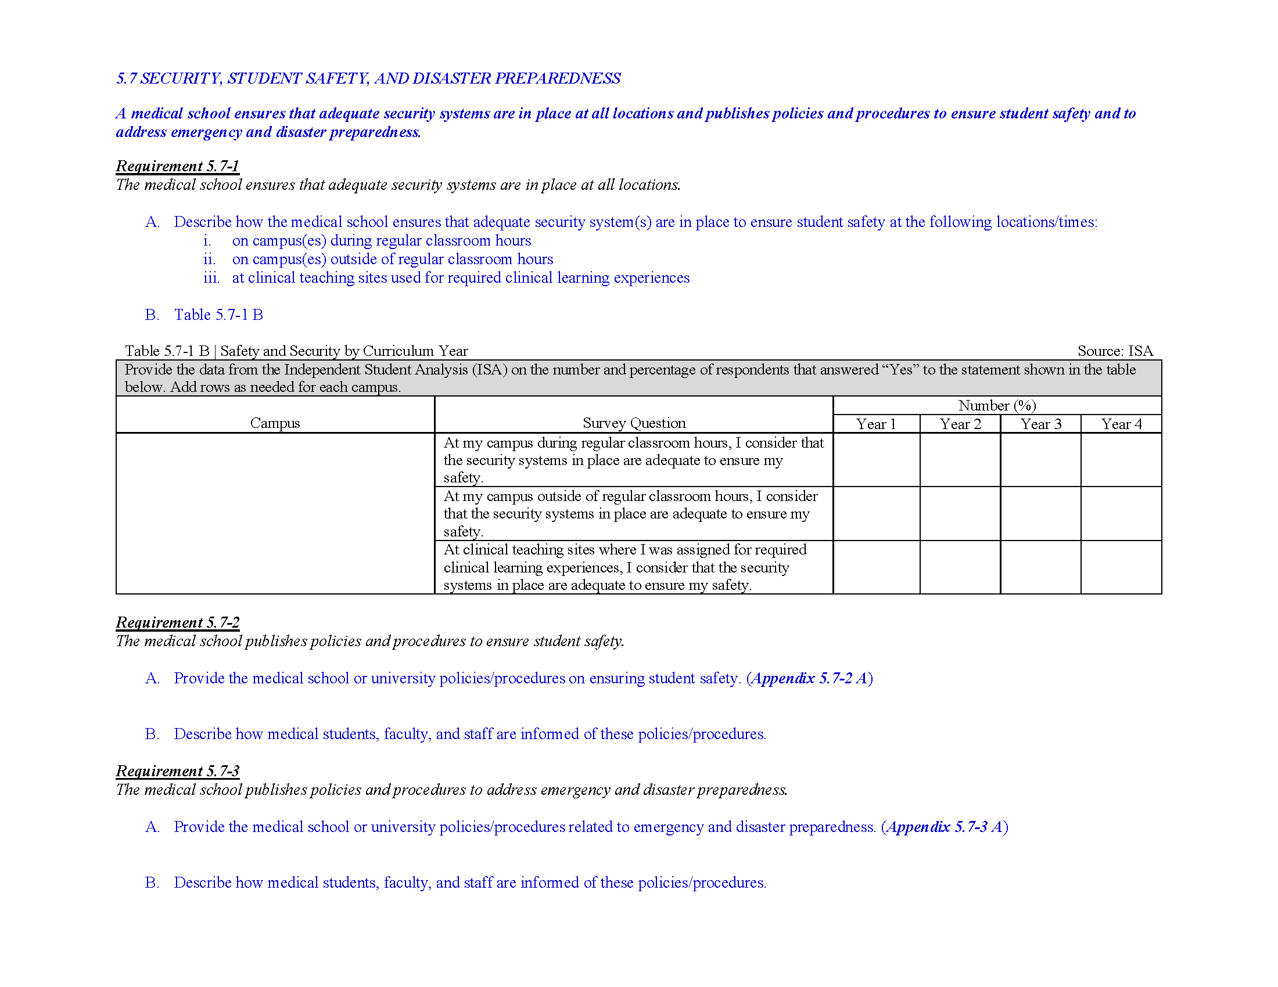
The DCI for element 5.7 is reproduced in the figure below. Element 5.7 has three requirements. Corresponding indicator questions (in blue font) are found below each requirement. This example also shows a data table, that when completed, will show tabular data from the ISA.

The main work of each subcommittee is to analyze the evidence presented in the DCI and then determine whether the evidence is sufficient to come to a decision on each requirement of an element and sufficient to determine an overall element satisfaction rating.

In cases where the subcommittee determines that the DCI is inadequate, then the subcommittee needs to be encouraged to file an interim report to the MSS steering committee a) to inform the steering committee of the problem and b) to receive guidance back from the steering committee as to potential next steps to obtain a revised version of the DCI.

The subcommittee may need to repeat the evidence gathering process described above until the members are satisfied that the DCI is adequate.

5.3 Completing the MSS element evaluation form
Each subcommittee completes an MSS element evaluation form for each of its assigned standards/elements. Shown below is the MSS element evaluation form for Element 5.7. For each element, subcommittees must complete three tasks, and they also have the option to provide continuous quality improvement (CQI) recommendations.

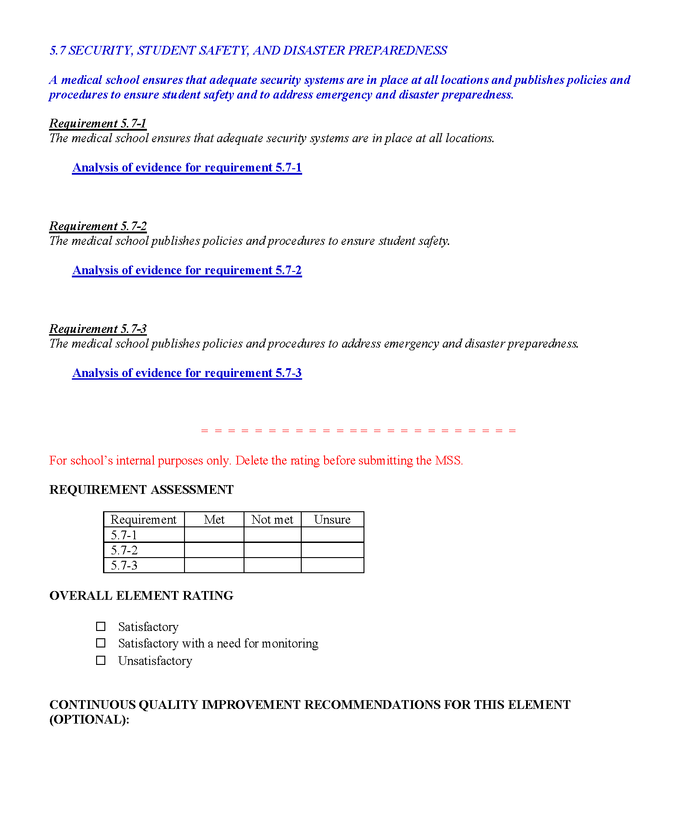

5.3.1 Completing the analysis of each requirement
The first task is to complete an analysis of the evidence for each requirement. In this example, Element 5.7 has three requirements, thus, the subcommittee must provide three analyses. Ultimately, these analyses will be part of the MSS report which will be reviewed by the CACMS visit team.

The analyses must consider responses to the indicator questions in the DCI associated with each requirement. To be of use to the steering committee, analyses of requirements need to be explicit, specific, objective, and sufficient to determine whether, in the opinion of the subcommittee, the requirement is met. In some cases a single paragraph or even a simple declarative statement of a fact may be sufficient for the analysis of a requirement.

5.3.2 Completing the Requirement Assessment table
Once all requirements are analyzed, the subcommittee completes the “Requirement Assessment” table. The Requirement Assessment table is for school’s internal purposes only and does not appear in the MSS report.

In the Requirement Assessment table, each requirement of the element is listed by its number. The subcommittee must determine whether in its opinion the requirement is met. If so, then an “X” is placed in the corresponding column. If, in the opinion of the subcommittee, the requirement is not met or the subcommittee is unsure, then an X must be placed in the corresponding column and reasons for the assessment must be clearly conveyed to the steering committee in the subcommittee’s analysis of the requirement. The unsure option is useful when consensus cannot be achieved within a subcommittee.

5.3.3 Completing the Overall Element Rating table
Once all requirements are marked as “Met” or “Not met” such that no “Unsure” ratings appear in the Requirement Assessment table, the Overall Element Rating can be recorded. The Overall Element Rating table is for internal use by the medical school and is not shared with the visit team or the CACMS.

The CACMS defines the conditions required for each potential overall rating, and the full definitions excerpted from the CACMS Rules of Procedure appear in Appendix 5.3.3 of this document. Members of the steering committee and its subcommittees MUST use these definitions when rating an element.

To merit a rating of Satisfactory (S), all requirements of the element must be met.

When one or more requirements are not met, the element must be rated Unsatisfactory (U).

The “Satisfactory with a need for monitoring” (SM) rating is used when all requirements are met, but one of two conditions also exists. Either 1) “the medical education program has the required policy, process, resource, or system in place, but there is insufficient evidence to indicate that it is effective”, or 2) “the medical education program’s performance currently is satisfactory with respect to the element, but there are known circumstances that could directly result in unsatisfactory performance in the near future.”

Subcommittees unsure of when to apply the SM rating are advised to have its chairperson contact the FUAL.

5.3.4 Completing the Continuous Quality Improvement (CQI) recommendations
Finally, the subcommittee may provide continuous quality improvement recommendations related to any element. Although recommendations in the CQI section of the form are optional and may not always be applicable, their inclusion can be invaluable for identifying areas of improvement for the medical school or its medical education program. Concise and explicit CQI recommendations that include timelines can be especially helpful providing direction for the resolution of U or SM ratings in advance of the accreditation visit, but CQI recommendations can be included even for those elements rated S.

The CQI recommendations are for the medical school’s internal use and are not shared with the visit team or the CACMS.

5.3.5 Submitting subcommittee reports to the steering committee
As mentioned in Section 3, (above), the MSS is an iterative process that can include multiple information exchanges between a subcommittee and the steering committee.

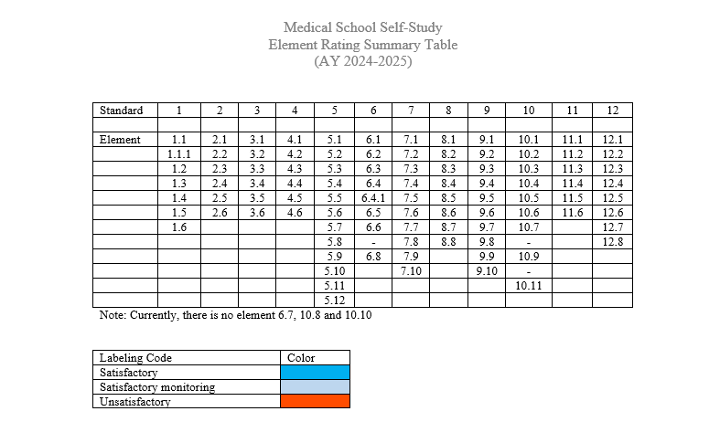
One or more element evaluation forms may comprise an interim report from a subcommittee to the steering committee. When submitting a final, or near final report, the subcommittee is encouraged to include an MSS Element Rating Summary Table showing recommendations for all assigned elements (see adjacent figure). This summary table can facilitate the work of the MSS steering committee and is not shared with the visit team or the CACMS.

Blank MSS Element Rating Summary Table forms are found on the CACMS website in the same section as other MSS documents (see section 5.1). Use the suggested colour scheme to identify recommendations for all elements analyzed.

6. Writing the MSS report
Once the steering committee has completed its review of all subcommittee reports and any supporting documentation (including the DCI and ISA), the MSS report to the CACMS can be drafted. Typically, the chair, or a small working group from within the steering committee will craft a first version of the report for subsequent review and approval by the steering committee. The report submitted to the CACMS is expected to have the structure outlined below.

6.1 Title page
The title page must include:
- Document name: Medical School Self-study
- Medical School name
- University name
- Date of completion

6.2 Table of contents
The table of contents must include entries for items 6.3 – 6.6 below. Within item 6.4 (below), the Table of contents must include a separate entry for the MSS evaluation forms of each of the twelve standards.

6.3. Introduction
The Introduction is comprised of the school’s prior accreditation history and a description of the self-study as detailed below:

- Prior accreditation history
Upon request, the CACMS Secretariat (contact: CACMS@afmc.ca) will provide a table listing the school’s compliance and satisfaction status with each standard and element, the type and timing of CACMS-requested follow-up, and the accreditation status of the medical education program since the time of the last full visit. Insert the table in the MSS report Introduction.

In one page or less, briefly summarize the steps taken to address any standards in noncompliance or in compliance with a need for monitoring and elements rated unsatisfactory or satisfactory with a need for monitoring that were identified at the time of the previous full visit.

- Description of the self-study process
In one page or less, provide a brief overview of how the MSS was conducted. Include a brief description of the level of participation by the various members of the academic community, including students.

6.4. Evaluation of elements
For the final MSS report that is submitted to the CACMS, the following items must be removed from the MSS evaluation forms:
- all element ratings or rating summary tables
- all Requirement Assessment tables
- all overall ratings of elements
- all CQI recommendations.

See Appendix 6.4 for an example of the structure to be used for each standard in this section of the report.

The MSS Element Evaluation forms are to appear in numerical order in the final MSS report.

6.5 MSS steering committee summary statement
Limit this component of the report to no more than 1 page.

Include in the summary statement a comment on the following points:
- The timeframe over which a) the steering committee and b) its subcommittees met.
- The level of participation in the work of the steering committee and its subcommittees
- When the DCI was made available to the steering committee.
- When the ISA tabular data and ISA final report were received by the steering committee.
- Level of student participation on the steering committee and subcommittees.
- Any contextual factors that may have affected the work of the committees.

6.6 Appendix
Participation on the MSS steering committee and its subcommittees

- Identify the members of the MSS steering committee and include the following information for each member:
- Name
- Role(s) within medical school or other institution (for students, include year in program)
- Campus affiliation (if applicable)

- Identify each subcommittee and its members. Include the following information for each member:
- Name (mark MSS steering committee members with an asterisk)
- Role(s) within medical school or other institution (for students, include year in program)
- Campus affiliation (if applicable)

7. Submission of MSS report
The final MSS report, in Word format, is to be submitted to the CACMS Secretariat via a file upload no later than three months in advance of the accreditation visit start date. Details on file upload can be obtained by contacting the CACMS Secretariat at: CACMS@afmc.ca.

8. List of Appendices

Appendix 5.3.3
Ratings for Elements, excerpted from the CACMS Rules of Procedure (2022), Section III, A.

Satisfactory (S):
- The required policy, process, resource, or system is in place and, if specified by the element, there
is sufficient evidence to indicate that it is effective.

Satisfactory with a need for Monitoring (SM):
- The medical education program has the required policy, process, resource, or system in place, but
there is insufficient evidence to indicate that it is effective. Therefore, monitoring is required to
ensure that the desired outcome has been achieved.
2. The medical education program’s performance currently is satisfactory with respect to the element,
but there are known circumstances that could directly result in unsatisfactory performance in the
near future. Therefore, monitoring is required.

Unsatisfactory (U):
- The medical education program has not met one or more of the requirements of the element. The
required policy, process, resource, or system either is not in place or is in place but has been found
to be ineffective.

Appendix 6.4
Report structure for section on evaluation of elements
MSS evaluation form for Standard 1 showing only element 1.1 as an example
In the final MSS report, element evaluation forms reporting on all seven elements of Standard 1 are to be included in this section.
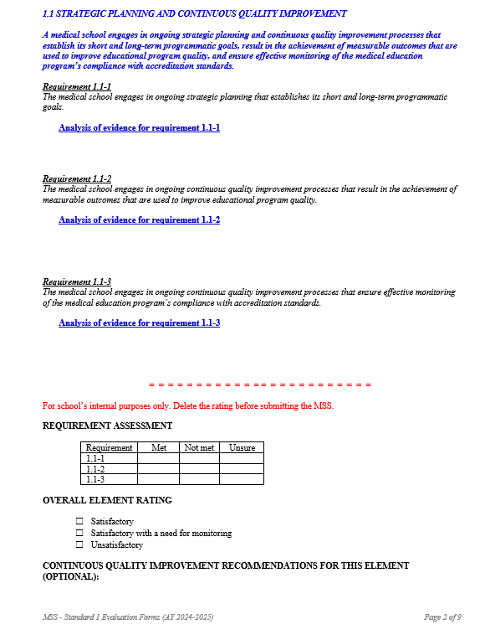
Original format
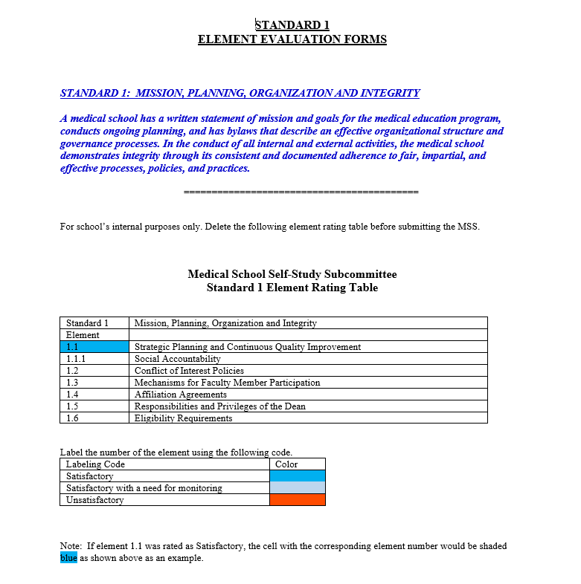
Format for use in final MSS report
