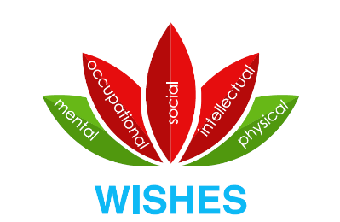

Wellness Innovation Scholarship for Health Professions
Education and Health Sciences (WISHES) Symposium
10 October 2019
Health Sciences Centre
Keynote Speaker:
Lauren Vogel
Journalist & News Editor, CMAJ
Using the media to increase learner wellness: Insights from the Canadian Medical Association Journal (CMAJ)
The Wellness Innovation Scholarship for Health Professions Education and Health Sciences (WISHES) is a virtual laboratory aimed at enhancing the learning experience at CSM by reducing stigma related to illness and creating a safe culture for help seeking. WISHES engages key stakeholders across the CSM, the University, as well as across the province and country to advocate for a more accessible and sustainable approach to managing learner wellness and illness. WISHES is bringing together practitioners and scholars alike to collaborate on learner wellness projects focused on the areas of mental health, physical health, occupational health, social health and intellectual health.
The inaugural WISHES Symposium will be held on October 10, 2019 from 11:00am-5:00pm at the Health Sciences Centre at the Cumming School of Medicine. This free event is open to anyone with an interest in learner and health practitioner wellness research and innovation, and will include a lunch and poster session, keynote address, local research presentations, and wellness challenge with prizes. A detailed schedule will be available in later September.
The Call for Abstracts is now open, with information available at: https://cumming.ucalgary.ca/office/ohmes
WISHES Symposium registration is now open at: https://wishes2019.eventbrite.ca
For further information, please contact wishes@ucalgary.ca

Wellness Innovation Scholarship for Health Professions Education and Health Sciences (WISHES) Symposium
Thursday, October 10, 2019
CALL FOR ABSTRACTS
The Wellness Innovation Scholarship for Health Professions Education and Health Sciences (WISHES) Symposium, sponsored by the Office of the Senior Associate Dean Education, will be held at the Health Sciences Centre at the University of Calgary on October 10, 2019. This symposium will showcase wellness research and innovation in health and medical education in Calgary and beyond, and is intended to encourage future collaborations among researchers with common interests.
Format: The symposium is scheduled from 11:00 to 17:00 on Thursday, October 10, 2019. It will feature keynote speakers, oral presentations and a wellness challenge.

Eligibility: Faculty, staff, and learners affiliated with a post-secondary institution are invited to submit abstracts based on learner (BHSc, GSE, UME, PGME) and practitioner (physicians, post-docs and other health care professionals) wellness in health or medical education research or innovation. Works-in-progress will also be considered.

Benefits: Participation in this event will provide researchers with an opportunity to present their work, to receive rich feedback from their peers, and to engage with scholars within the Cumming School of Medicine (CSM) and beyond. The CSM and health and medical education community also benefit from your participation, as you contribute to a growing field of scholarly work by disseminating your research.

Abstract Submission: Investigators interested in submitting an abstract for review must provide a brief overview of their research or innovation. The submission is limited to 250 words maximum, using the attached form as a template. Multiple submissions by collaborators are allowed. Please submit the abstract submission form to wishes@ucalgary.ca on or before the deadline of 4:00PM MST, Friday, September 27, 2019. Authors will be notified by October 1, 2019 of their acceptance.

If you have any questions regarding the Call for Abstracts or the Symposium, please contact WISHES at wishes@ucalgary.ca or (403) 220-4342. We look forward to your submissions!

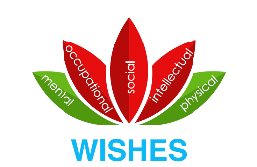

Wellness Innovation Scholarship for Health Professions
Education and Health Sciences (WISHES) Symposium
10 October 2019
ABSTRACT SUBMISSION

Presentation Title:

Lead Author:

Presenting Author Institution/Affiliation:

Presenting Author Phone and Email:

Co-Authors and affiliations and email (max 4):

Preferred format:
☐ Oral Presentation
Oral presentations provide an opportunity to share your research or innovation with our wellness scholarship community in an intimate classroom setting. Presentations will be limited to 15 minutes total per project (ie. 10 minutes presentation plus 5 minutes for questions). Please note that oral presentation slots are limited. You may submit works in progress, provided that results can be presented at the event.
☐ Poster Presentation
A poster session will be held in the atrium during lunch, and will be on display for the entire event. Presenters are expected to be available at their poster to informally present and answer questions only during the lunch session time. Posters previously presented at other conferences are welcome.

Please use the following subsections to present your abstract for Oral or Poster Sessions. Maximum 250 words.

Background:

Objectives or Questions:

Methods:

Results and Findings:

Conclusions and Significance:

___________________________________________________________________________________________

Please email this form to wishes@ucalgary.ca by 4:00PM MST Friday, September 27, 2019.

