Health and Medical Education Scholarship Symposium Agenda
8:00-8:30 | REGISTRATION & CONTINENTAL BREAKFAST | Theatre 3 Lobby
8:30-9:00  9:00-9:30  9:30-10:00  10:00-11:00 | Welcome and Introduction to OHMES  Dr. Jocelyn Lockyer & Dr. Ian Mitchell  The “5 Fs” of research pursuits: How a simple GI doc managed to publish anything  Dr. Sylvain Coderre  What constitutes good scholarship?  Dr. Farhan Bhanji  If you’ve seen one: Deconstructing community relationships in medical education  Dr. Rachel Ellaway | Theatre 3
11:00-11:15 | COFFEE BREAK | HRIC Atrium
11:15-12:15 | POSTER SESSION | HRIC Atrium
12:00-12:45 | LUNCH | HRIC Atrium
12:45-1:45 | Early investigations into the nature of experience and expertise in clinical reasoning  Dr. Meredith Young | Theatre 3
2:00-3:30 | WORKSHOP A: Examining changes in the CanMEDS roles in 2015 and competency based medical education  Dr. Farhan Bhanji  WORKSHOP B: Measuring performance in blended simulation scenarios  Dr. David Topps  WORKSHOP C: Publishing in health professional education – Why is dissemination important and is your study publishable?  Dr. Kent Hecker & Dr. Aliya Kassam | O1504 HSC  O1506 HSC  O1509 HSC
3:30-4:30 | NETWORKING RECEPTION | HRIC Atrium
CUMMING SCHOOL OF MEDICINE
Office of Health and Medical Education Scholarship
Health and Medical Education Scholarship Symposium
Tuesday, February 17, 2015
Health Sciences Centre, University of Calgary
Welcome to the Scholarship Symposium!
The Office of Health and Medical Education Scholarship (OHMES) welcomes everyone to the first Health and Medical Education Scholarship Symposium. The intent of this event is to showcase work in health and medical education scholarship, and to encourage collaborations among researchers with common interests. We are excited to welcome local and national experts in education scholarship, and look forward to the conversations we hope this event will start.
OHMES was established in 2014, with a mission to “capitalize on the high quality education programs and the cadre of excellent current and potential educational scholars, and provide support to bring these activities to a higher level”. In order to achieve this, we have created services and events to develop scholarship capacity. We encourage you to visit www.cumming.ucalgary.ca/ohmes to learn more about our consulting service, funding competition, travel fund, workshops, and seminars. Today’s Symposium is our flagship event, and we look forward to your participation and feedback. Enjoy the day!
Dr. Ian Mitchell, Director, OHMES
Dr. Nishan Sharma, Chair, Symposium Planning Committee
TWEET US
We are interested in your thoughts during the event! Join us @UCalgaryOHMES or use #OHMESsymposium
FEEDBACK
We would appreciate your feedback on this event. Future events will be based on your comments, and we want to know what you liked as well as suggestions to improve the Symposium. Please complete the evaluation form and return it to one of the marked boxes at the registration table or in the HRIC Atrium.
CE CREDITS
MAINPRO-M1 – 6.0 credits
MOC Section 1 – 6.0 credits
Alberta Veterinary Medical Association – 6.0 CE hours
Certificates of Attendance will be issued by email.

Poster Presentations (cont.)
Are Canadian undergraduate curricula providing future physicians sufficient clinical experience in palliative care? | Mone Palacios
How is it for you? Residents’ and preceptors’ experience with a new family medicine competency-based curriculum | Mone Palacios
The medical students’ perspective of formal and informal mentors | Jay Park
Exploring stakeholder engagement within strategic clinical networks in Alberta | Léora Rabatach
Communication about goals of care in postgraduate medical education: An exploration of contextual factors | Amanda Roze des Ordons
Into to Code Blue (ITCB): Combining resident-as-teachers with acute care simulation training for medical students | Anthony Seto
An online module for teaching the mental status exam | Sterling Sparshu
Systematic review of evidence-based medicine tests for family physician residents | Roger Thomas
Dynia – a unique combination of script concordance testing, virtual patients, webinars and forums for assessing knowledge translation in chronic pain | David Topps
This event would not have been possible without the support of the following people:
SYMPOSIUM PLANNING COMMITTEE
Dr. Nishan Sharma (Chair)
Dr. Kent Hecker
Dr. Aliya Kassam
Dr. Doug Myhre
Dr. Ian Mitchell
Thank you to all of our presenters, workshop facilitators, and poster presenters for sharing your research and expertise! There would be no event without you.
Thank you to our volunteers from the O’Brien Institute for Public Health and W21C!

Poster Presentations
The effect of adopting team-based learning on the attainment of learning objectives in an undergraduate medical education evidence-based medicine course | Fariba Agharjafari  Franco Rizzuti
Hydroxyurea for β -Thalassemia Major: A meta-analysis | Ali Algiraigri
Teaching cognitive biases that lead to diagnostic errors using high-fidelity human patient simulation: The next level of conversation with learners at the point of care | Ghazwan Altabaa
A neuroeducational approach to understanding 2D anatomy learning – task optimization for measurement of neural processes | Sarah Anderson
Factors that influence the implementation of knowledge translation tools | Heather Armson
Physicians’ perceptions of the impact of external feedback on identifying practice gaps, increasing knowledge and guiding practice change | Heather Armson
Canuc-paeds – The Canadian undergraduate curriculum in paediatrics: A collaborative venture | Susan Bannister
The flipped classroom improves exam performance in undergraduate medical education | Kelly Burak
International medical graduates’ experiences with cross-cultural doctor-patient communication | Marianna Hofmeister
Evaluating the impact of mindfulness meditation on family medicine residents’ well-being | Joan Horton
Improving an undergraduate mentorship program: A mixed methods study | Deirdre Jenkins
Impact of peer pressure on accuracy of reporting vital signs: A comparison between nursing and medical students | Alyshah Kaba
Collaborative practice in action: An interprofessional collaboration (IPC) competency based simulation education intervention for preceptors and clinical faculty | Alyshah Kaba
SHARCFM: The shared Canadian curriculum in family medicine | David Keegan
Integrating SHARC-FM virtual patient cases in the family medicine clerkship curriculum | Martina Kelly
Facilitating feedback: Developing a model to promote engagement, acceptance and practice improvement | Jocelyn Lockyer  Heather Armson
CARDS: Rebooting online clinical problem solving for educating physicians | Mike Paget
Medical student proficiency with ophthalmology diagnoses and technical skills | Mathew Palakkamanil

Keynote Speakers & Workshop Facilitators
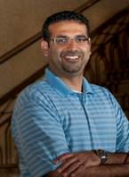
Farhan Bhanji, MD, FRCPC, MSc
Dr. Bhanji completed medical school at the University of Western Ontario and his Pediatrics residency at the Montreal Children’s Hospital (MCH) of McGill University, with subsequent fellowships in Pediatric Critical Care and Pediatric Emergency Medicine. He is an Associate Professor of Pediatrics and works clinically in both the Pediatric Intensive Care and the Pediatric Emergency Department - where he also serves as the fellowship program director.
Dr. Bhanji graduated from the Masters of Science in Health Professions’ Education from Maastricht University in 2008 and is the inaugural Richard and Sylvia Cruess Faculty Scholar (Medical Education Research) at the Centre for Medical Education, McGill University. He recently took over as the Program Director of the McGill University Fellowship in Medical Education. Dr. Bhanji is involved nationally and internationally in resuscitation-based education and is actively conducting research in the domain. In August 2013, Dr. Bhanji joined the Royal College of Physician and Surgeons of Canada as Associate Director, Assessment. He oversees post graduate assessment policies, programs and development.
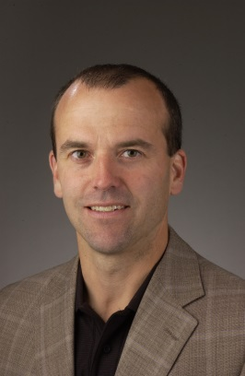
Sylvain Coderre, MD, FRCPC, MSc
Dr. Coderre is the Associate Dean, Undergraduate Medical Education (UME), a professor in the Department of Medicine and a member of the Division of Gastroenterology. His clinical specializations are Gastroenterology and Internal Medicine. He completed his medical training at the University of Ottawa in 1997, and joined the University of Calgary’s Cumming School of Medicine as a Clinical Assistant Professor in 1997. In 2001, he completed his Master of Science in Medical Education at the University of Calgary.
His career in education has included teaching and leadership roles in undergraduate, postgraduate, and continuing medical education. As Assistant Dean, UME, he helped to shape the current three-year undergraduate program curriculum, as well as teaching delivery and evaluation methods within the program. His areas of interest in medical education are cognitive psychology, clinical reasoning and technical skills training.
Keynote Speakers & Workshop Facilitators
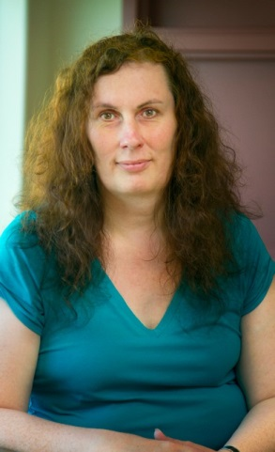
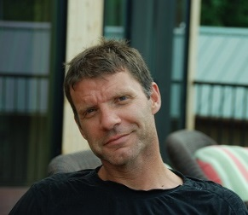
Rachel Ellaway, PhD
Dr.Ellaway is the Assistant Dean Curriculum and Planning and an Associate Professor at the Northern Ontario School of Medicine. Her academic work concentrates on educational systems and ecologies, the use of new technologies for teaching and assessment in and around health professional education, and critical perspectives on developments in health professional education. Dr. Ellaway is the instigator and ongoing Maitresse des Ceremonies for the AMEE Fringe, the author of the eMedical Teacher column in the journal Medical Teacher, and an editor of Advances in Health Sciences Education.
Kent Hecker, PhD
Associate Professor (Veterinary Medical Education)
Veterinary Clinical and Diagnostic Sciences (VCDS)
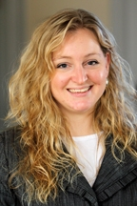
Community Health Sciences (CHS)
Dr. Hecker received his PhD in medical education research in 2007. He joined the Faculty of Veterinary Medicine at the University of Calgary as the Director of Admissions in 2007 and began as an Assistant Professor in 2008. Dr. Hecker has built a program of basic and applied educational research in three primary areas: 1) curriculum/program design and evaluation; 2) assessment of competencies in the health care professions; and 3) educational measurement and assessment issues within institutional and non-institutional settings.
Aliya Kassam, PhD
Dr. Kassam is an Assistant Professor in the Department of Community Health Sciences, University of Calgary. She currently is the research lead in the Office of Postgraduate Medical Education where she has projects looking at fatigue management in residents, as well as multisource feedback. Dr. Kassam teaches workshops on Biostatistics, Patient Safety and Health Research Methods to residents. She is an active supervisor in the MSc Medical Education Specialization Program where she teaches the course on Systematic Reviews/Meta-Analysis in Medical
Education. Her academic background includes an undergraduate honours degree in Psychology and a Masters in Epidemiology from the University of Calgary. Dr. Kassam also has a PhD in Health Services Research from King’s College, London, England.
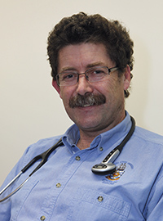
Her research interests pertaining to medical education and health services research include social responsibility, health advocacy, patient-centred care, quality improvement, psychometrics, and survey development.
David Topps, MD
Dr. Topps is a Family Medicine Professor at the University of Calgary. He was previously Director of Clinical Informatics at the Northern Ontario School of Medicine, with over 20 years of experience in educational technology, mobile communications and ubiquitous computing. A family physician by background, he has worked in rural and remote medicine since 1984, turning to academic medicine in 1997. He has worked and taught in Canada, Australia and the United Kingdom, and has been part of a number of international collaborative projects. Current areas of research include digital professionalism, virtual patients, and mixed modality simulation in inter-professional education.
Meredith Young, PhD
Dr. Young is an Assistant Professor in the Department of Medicine and a Research Scientist in the Centre for Medical Education at McGill University. She received her PhD in cognitive psychology from McMaster University in 2009. She has two main areas of research; the basic science of how individuals (both with and without medical expertise) think through a variety of complex problems in medicine, and issues surrounding validity in assessment of health professions education. More specifically, she studied the intersection of more intuitive decision-making and more structured, rule-based reasoning, and how conceptions of validity affect how we assess in health professions education.

