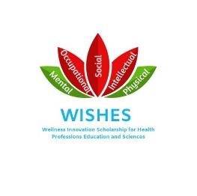
Wellness Innovation Scholarship for Health Professions Education and Sciences (WISHES)
ADVISORY COMMITTEE
Terms of Reference
Role
The Advisory Committee advises WISHES on matters relating to program development and operations, which are aligned with the goals of the Cumming School of Medicine, University of Calgary.
Reporting Structure
The WISHES Advisory Committee reports to the Senior Associate Dean Education and the Senior Education Committee.
Responsibilities
- Create a platform to unify and increase inter department/faculty wellness scholarship initiatives
- Determine themes and goals for WISHES and related programs/events
- Promote WISHES through communications with the education community, eg. presentations on WISHES initiatives, etc
- Report on program development and operations quarterly to Senior Associate Dean Education and Senior Education Committee
Membership Terms
The following representatives may serve on the Executive Committee for a term defined by their continued affiliation with their position/program/department:
- Senior Associate Dean Education (CSM)
- Undergraduate Medical Education (CSM)
- Student Advising and Wellness Office (UME-CSM)
- Postgraduate Medical Education (CSM)
- Office of Resident Affairs (PGME-CSM)
- Graduate Science Education (CSM)
- Bachelor of Health Sciences (CSM)
- Faculty of Nursing
- Faculty of Social Work
- University of Calgary Mental Health Strategy
- University of Calgary Student Wellness
- Office of Health and Medical Education Scholarship (CSM)
- Director of Physician Wellness (OPED-CSM)
- Department of Family Medicine
- Department of Psychiatry
- Mathison Centre for Mental Health Research & Education (CSM)
Meeting Frequency
The Advisory Committee meets quarterly, or as needed.

Approved By:
WISHES Advisory Committee 23/05/19

