Molecular Services

Development of PCR Assay (short) $100.00
Development of PCR Assay (long) $250.00
Genotyping mice 1st PCR $8.00
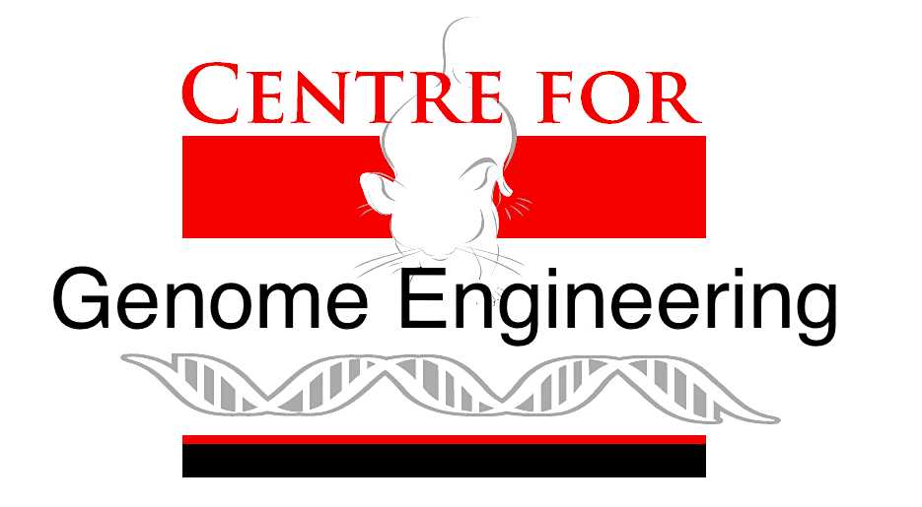
Genotyping mice 2nd PCR $12.00 ($8.00 + $4.00)
PCR Confirmation of Founders $8.00
Mycoplasm Testing $25.00 (first sample, $15.00 each after run at same time)
Custom Somatic cell KO via CRISPR $5,000.00
Design/Construction of Vector $3,000.00 - $5,000.00
Preparation of Vector $200.00 - $500.00
Technical Time $54.00/hr

ES Cell Services

Gene Targeting $5800.00
HPRT Targeted Transgenic $2,500.00
mES Cell line Derivation $1,500.00
Chromosome Counts $75.00 - $200.00
Cre Excision $3,500.00/50 clones
ES Cell Subcloning $500.00 - $1,500.00
ES Cell Expansion $300.00 - $1,000.00
Preparation of ES Cells for Agg/MI $350.00 - $500.00 per clone
MEFs $0.25 - $0.38/cm²
Primary MEFs $160.00/vial
Technical Time $54.00/hr

Transgenic Services

ES Cell Aggregation $2,875.00
ES Cell 8-cell Microinjection $2,875.00
ES Cell Microinjection Blastocyst $4,830.00
Pronuclear Microinjection plasmid $4,255.00 - $4,755.00
Pronuclear Microinjection BAC $4,255.00 - $4,755.00
Pronuclear Microinjection CRISPR KO $3,500.00
Pronuclear Microinjection CRISPR CKO $5,000.00
Frozen Embryo Rederivation Transfers $300.00
Frozen Sperm IVF Rederivation and ET $1,000.00 - $1,500.00
Vasectomies $35.00 (supply own mouse)
Ovariectomies $35.00 (supply own mouse)
Sperm Cryopreservation with QC $750.00
Annual Cryopreservation storage fees $105.00 per line
Embryo Cryopreservation with QC $1,000.00 - $2,000.00
Embryo Collection and Harvest e0.5-e3.5 $21.00 (supply own mouse)
Embryo Collection and Harvest e4.5 – e18.5 $44.00 (supply own mouse)
100, 2-cell CD1E x CD1E embryos $3.28/embryo
100, 2-cell C57BL6 x BDF1 embryos $6.57/embryo
IVF generated embryos $400.00 - $500.00 (5 females)
Technical Time $54.00/hr

Comprehensive Service (Molecular, Cell and Transgenic Services combined services)

ES Cell Targeted Mouse $20,000.00 - $25,000.00
CRISPR KO Custom Somatic Cell Line $5,000.00 + (PI supplied antibodies/media)
CRISPR KO Mouse $3,500.00 - $10,000.00
CRISPR CKO Mouse $8,000.00 - $12,000.00
CRISPR small KI Mouse $3,500.00 - $10,000.00

