

Using Copilot Chat to Help You with Your Clinical/Adjunct/Research (CAR) Promotions Submission


Helping summarize your activities
As part of the CSM Clinical/Adjunct/Research (CAR) Promotions Submission process, you will be asked to provide information regarding your performance in your administrative/service, research/scholarship, and/or education/teaching activities. Many of these activities may already be well documented in your CV, but that document is likely too long to be used for this purpose without summarizing the relevant information. This is where AI can help. At the University of Calgary, Microsoft Copilot Chat is available for your use, and we have provided instructions below on how to use it to help you craft your cover letter.
What is Copilot Chat?

Copilot Chat is a generative artificial intelligence (AI) tool created by Microsoft. It can be used to brainstorm and get answers to questions, organize and summarize documents and generate text, images and more.
Learn more about using Microsoft Copilot Chat
at the University of Calgary

Can I safely use Copilot with my data?
There are two versions of Copilot Chat:

- A secure version* is available for anyone with a UCalgary IT account. To keep your data protected, you must sign in using your UCalgary credentials. You’ll know you’re using the secure version if you see the green shield (see images below). With the secure version of Copilot Chat, you can safely enter level 1, 2 or 3 information.
- The public version can only be used for public information classified as level 1.
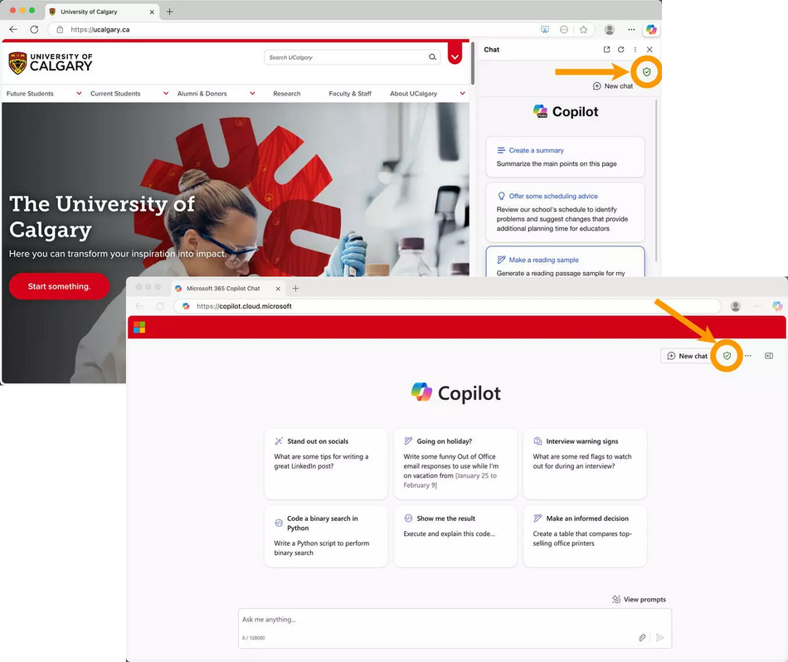
*How can you tell if you are using the secure version of
Copilot Chat? Look for the green shield!

Sharing confidential or personal information in any chatbot or automated system comes with risks. Using the secure version of Copilot Chat offers better security, privacy and protection of data. It also complies with UCalgary policies and standards.

How do I access Copilot Chat?
You can access Copilot Chat in three ways:
- In the Microsoft Edge browser, where Copilot Chat is built-in
- By visiting the Copilot Chat website in any web browser (https://copilot.cloud.microsoft/)
- By using the desktop icon on your managed UCalgary computer
How can Copilot help me with my CAR promotion submission?
If you have an up-to-date CV which you would use to draw information from to create your summarized answers for the various questions in the CAR form, you can get Copilot Chat to take a first crack at summarizing this information for you.


First, check to make sure you are using the secure version of Copilot Chat.
This will ensure the data you enter will be secure and not shared with Microsoft’s public AI. You are looking for the green shield icon, as seen to the right (and in the screenshots above).

Second, download the shortened CAR Promotions Criteria document from here.
You will use this document to help provide Copilot Chat with more information for it to work with.

Third, drag and drop the following two files into the “Message Copilot” box:
1) your CV file and 2) the shortened CAR Promotions Criteria document, which you should have just downloaded in the previous step.
(Alternatively, you can use the paperclip icon seen below to search for the files and upload them.)


Fourth, copy the following instructions and paste them into the same “Message Copilot” box.
Make sure to update the blanks below with your personalized information.

Draft a first-person cover letter based solely on the uploaded CV and shortened CAR criteria document. Do not include any information that is not explicitly stated in this prompt or in the CV.

Current Appointment: I am currently a CAR [replace this with your current rank, i.e., “Assistant” or “Associate”] Professor.

Time Since Last Promotion/Initial appointment: My last promotion/initial appointment was in [replace this with the year of your last promotion or initial appointment] to [replace this with your current rank] rank.

Primary and Secondary Pillars of Academic Activity: My primary pillar is [replace this with your primary pillar, i.e., Administrative/Service, Research/Scholarship, or Education/Teaching]. My secondary pillar, if applicable, is [replace this with your secondary pillar].

Summary of Contributions and Alignment with Promotion Criteria: Provide a brief summary of my most significant and impactful contributions, highlighting how these align with the criteria — use my CV and the shortened CAR criteria document to build this. Use bullet points or short paragraphs and indicate the pillar(s) of academic activity associated with each contribution. For research/scholarship, include relevant metrics of impact; for education/teaching, describe my scope and influence as an educator; and for administrative/service, outline my leadership reach and systems-level impact. Only activities within my identified primary and secondary pillars of academic activity. Any activities that might otherwise fall under a third pillar should be reclassified, where appropriate, within my primary or secondary pillar to ensure they are counted. [Copy and paste any specific CV items you would especially like to highlight]

Advancing UCalgary: Provide a brief summary of how my work advances the University of Calgary, including contributions that strengthen the functioning and growth of the university, its departments, and the broader academic community. For work conducted externally, demonstrate how it aligns with the university’s missions of teaching, research, and service, and how it enhances the university’s reputation and impact at the local, national, or international level. [Provide any additional direction here regarding the key elements you would like Copilot to specifically include.]

Additional Parameters: Do not exceed 3,000 characters and do not specify what promotion level I am applying for.

Fifth, review the information Copilot Chat provides you and make any necessary revisions.
The cover letter you will get from Copilot Chat probably won’t be perfect. It is essential that you review the letter and correct any errors or omissions. While this part will still be a manual part of the process, the letter Copilot Chat provides you will hopefully give you a significant head start in crafting the information you wish to include in your CAR submission.

Finally, submit the cover letter into the CAR submission form.
Once you have refined what Copilot Chat has given you, made any necessary revisions, and are satisfied with the information, you are ready to add it to the CAR submission form. You can either copy and paste it into the text box provided for your cover letter, or you can save your letter as a PDF and upload that instead.

